**Jai Hind Educational Trust’s**

**ZULAL BHILAJIRAO PATIL COLLEGE, DHULE.**

**Department of Commerce & Management**



**A Project Report on**

**Social Media Website (Socialnest)**

**For**

**Under Guidance of**

**(Name)**

**Submitted By**

**Lakade Mahesh Santosh**

**In partial fulfilment of the degree of**

**B.C.A (Bachelor of Computer Application)**

**AT**

**JAI HIND EDUCATION TRUST’S**

**ZULAL BHILAJIRAO PATIL COLLEGE, DHULE**

**NORTH MAHARASHTRA UNIVERSITY, JALGAON.**

**(Year: 2023 -2024)**

**Jai Hind Educational Trust’s**

**ZULAL BHILAJIRAO PATIL COLLEGE, DHULE.**

**Department of Commerce & Management**



**CERTIFICATE**

**This is to certify that Lakade Mahesh Santosh**

**Have successfully completed the project entire**

**“SOCIAL MEDIA WEBSITE (SOCIALNEST)”**

**He has submitted the report in the partial fulfilment of the degree in BCA (Bachelor of Computer Application) in academic year 2023-2024.**

**(Name) (Name)**

**Project Guide Head of Department**

**Examiner Examiner**

**Place: Dhule.**

**Acknowledgement**

I would like to thank Prof. Dr .P. H. Pawar sir the Principal of Jaihind Educational Trust's **ZULAL BHILAJIRAO PATIL COLLEGE,DHULE** for his precious suggestion, motivation and support in the project report.

I would like to thank Asst. Prof. P. G. Adawadkar sir, Head,Faculty of Commerce and Management for providing an opportunity to learn through project report work, by the medium of project. I consider myself to be fortunate to get this opportunity to explore in the project report of “**Social Media Website**”. I am sincerely grateful to her for his valuable guidance, motivation and support at all stages of all project work, right from conception of idea to the finalization of project work and creating in a flexible and enjoyable environment to work.

I am thankful of Faculty of Commerce and Management for constant Inspiration in the pedagogical world of Bachelor of Computer Application.

**Mahesh Lakade**

**(T.Y.B.C.A.)**

***INDEX***

|  |  |  |
| --- | --- | --- |
| **Sr. No.** | **Content** | **Page No.** |
| **1** | **Introduction to Organization** | **5** |
| **2** | **Proposed and Existing System** | **6** |
| **3** | **Need Of Computerization** | **8** |
| **4** | **Introduction to Environment** | **9** |
| **5** | **Data Collection And Analysis** | **11** |
| **6** | **Hardware & Software Requirement** | **17** |
| **7** | **Feasibility Study** | **18** |
| **8** | **Entity Relationship Diagram** | **19** |
| **9** | **Dataflow Diagram** | **20** |
| **10** | **Data System Input & Output** | **22** |
| **11** | **Testing & Implementation** | **28** |
| **12** | **Suggestion & Conclusion** | **30** |

CHAPTER-I

**INTRODUCTION TO ORGANIZATION**

**Introduction About Organization:-**

**Name Of The Organization :- “Social Media Website”.**

**Location :- Dhule**

**Proprietor :- Mahesh Lakade**

**“Social Media Website”** is a dynamic entity committed to technological innovation and societal connection. With a vision to harness the power of digital communication, the organization embarks on a project to develop a cutting-edge social media website.

Founded on principles of user-centric design and privacy, the organization strives to redefine the landscape of online social interaction.

Our Vision:

At Social Connect Hub, we envision a world where individuals can seamlessly connect, share, and collaborate in a digital space that prioritizes user-centric design, privacy, and cutting-edge features. We believe in the transformative potential of technology to bring people together, transcending geographical boundaries and enriching lives through meaningful interactions.

Mission Statement:

Our mission is to develop a state-of-the-art social media website that goes beyond traditional platforms, offering users a dynamic and user-friendly space where they can express themselves, build communities, and engage with content that resonates with their interests. Social Connect Hub is committed to creating an inclusive and secure online environment that empowers individuals to connect authentically.

CHAPTER-II

**PROPOSED & EXISTING SYSTEM**

**Existing system:-**

The current social media landscape is characterized by platforms that, while effective, often lack advanced features and fail to meet the evolving expectations of users. Challenges such as privacy concerns, limited real-time communication capabilities, and a need for innovative functionalities present opportunities for improvement in existing systems.

The existing system of social media platforms often exhibits several common characteristics:

**Feature Set**: Many existing platforms provide standard features such as user profiles, news feeds, messaging, and multimedia sharing.

**Privacy Concerns**: Users often express concerns about data privacy, with incidents of unauthorized access and data breaches affecting user trust.

**User Interface**: While functional, some platforms may have user interfaces that are complex, leading to a learning curve for new users.

**Proposed system:-**

The proposed social media website envisions a platform that goes beyond the conventional, aiming to redefine the user experience by introducing innovative features, enhancing privacy, and fostering a vibrant community atmosphere. Here's a detailed explanation of the key aspects of the proposed system:

**Innovative Features**: The proposed system incorporates unique features, such as [Real time chat], to provide users with a novel and engaging experience.

**Enhanced Privacy Measures**: Robust security measures, including end-to-end encryption for messages and granular privacy controls, are integrated to safeguard user data and privacy.

**User-Centric Design**: The user interface is designed with a focus on simplicity and intuitiveness, ensuring that users, both new and experienced, can navigate the platform effortlessly.

**Transparent Content Algorithms**: The content curation algorithms are designed to be transparent, providing users with more control over the content they see and promoting a sense of openness.

**Community Building Tools**: The proposed system emphasizes community building by introducing tools and features that encourage the formation of authentic and supportive communities.

**Accessibility and Inclusivity**: The platform is designed to be accessible to users with diverse abilities, ensuring an inclusive online environment for all.

By addressing the shortcomings of the existing system and incorporating innovative solutions, the proposed social media website aims to provide users with a more enriching and user-friendly experience while prioritizing their privacy and security.

CHAPTER-III

 **NEED OF COMPUTERIZATION**

Computerization is crucial for the successful development and operation of a social media website, providing a range of benefits that contribute to its functionality, efficiency, and user experience. Here are some key reasons highlighting the need for computerization in the context of a social media platform:

1. Scalability: Computerization allows for the efficient handling of large volumes of data and user interactions. As a social media website grows, computerization ensures scalability, allowing the platform to handle an increasing number of users, posts, and interactions seamlessly.

2. Real-Time Interactivity: Social media is inherently dynamic, requiring real-time processing of user activities such as posting, commenting, and messaging. Computerization enables the instantaneous handling of these interactions, providing users with a responsive and engaging experience.

3. User Authentication and Security: Computerization allows for robust user authentication processes, securing user accounts and preventing unauthorized access. Additionally, it enables the implementation of security measures such as encryption to safeguard user data and privacy.

4. Cross-Platform Accessibility: Social media users access platforms from various devices and locations. Computerization ensures cross-platform accessibility, allowing users to connect seamlessly from desktops, laptops, tablets, and mobile devices.

In essence, computerization is the backbone of a social media website, providing the necessary infrastructure and capabilities to deliver a seamless, interactive, and secure experience for users. It empowers the platform to evolve, adapt, and thrive in the dynamic and ever-changing landscape of online social interactions.

CHAPTER-IV

 **Introduction to Environment**

The technological environment in which a social media website operates is a dynamic and interconnected ecosystem, comprising various web development languages and technologies. Understanding this environment is fundamental to the creation of a robust, interactive, and data-driven social media platform. Here's an introduction to the environment, highlighting the key technologies involved:

1. HTML (HyperText Markup Language):

HTML serves as the foundation of the social media website's structure. It defines the layout and organization of content, allowing for the creation of user interfaces, profiles, posts, and other essential elements. HTML5, with its enhanced multimedia capabilities, is particularly crucial for supporting a rich and dynamic user experience.

2. CSS (Cascading Style Sheets):

CSS is employed to style and visually enhance the elements created with HTML. It governs the website's appearance, including color schemes, fonts, layouts, and responsive design. CSS ensures a cohesive and visually appealing presentation across various devices and screen sizes.

3. PHP (Hypertext Preprocessor):

PHP is a server-side scripting language that powers the backend functionality of the social media website. It enables dynamic content generation, user authentication, and database interactions. PHP plays a vital role in processing user requests, managing sessions, and ensuring the secure execution of server-side operations.

4. JavaScript:

JavaScript is a client-side scripting language that enhances the interactivity of the social media platform. It enables the creation of dynamic features, such as real-time updates, interactive forms, and asynchronous communication. JavaScript, when used with frameworks like React or Angular, contributes to a more responsive and engaging user interface.

5. MySQL:

MySQL is a relational database management system used for storing and retrieving data efficiently. In the context of a social media website, MySQL is crucial for managing user profiles, posts, comments, and other relational data. It ensures the integrity and reliability of the data storage system.

6. Security Measures:

Security considerations are paramount in the web development environment. Technologies such as HTTPS, secure PHP coding practices, and client-side validation using JavaScript are essential for protecting user data, ensuring secure logins, and preventing common web vulnerabilities.

7. AJAX (Asynchronous JavaScript and XML):

AJAX is employed to facilitate asynchronous communication between the browser and the server. This enables real-time updates, reducing the need for page reloads. AJAX, often used with JavaScript, contributes to a more dynamic and responsive user experience on the social media website.

In summary, the technological environment for a social media website is a synergistic blend of HTML, CSS, PHP, JavaScript, MySQL, and other supporting technologies. A successful social media platform requires a comprehensive understanding of these technologies to create an engaging, secure, and user-friendly online environment.

CHAPTER-V

 **DATA COLLECTION & ANALYSIS**

**DATA DICTIONARY**

A data dictionary is ‘metadata’ is i.e. about data. Data dictionary is list of all data element composing the data flowing thought a system major complaint are data flow, data stores and stores process. I have tried my level best to conserve storage space in this project. Even though there is a large amount of data element on proposed system. Still there is fountain system. The following section gives of detail element.

* **Database Name: socialnest1 (admin Table)**

**Purpose: To Store the information about the Admin.**

|  |  |  |  |  |
| --- | --- | --- | --- | --- |
| Serial No | Field Name | Data Type | Field Size | Constraint |
| 1 | id | int | 11 | Primary Key |
| 2 | full_name | Varchar | 250 | NOT NULL |
| 3 | email | Varchar | 250 | NOT NULL |
| 4 | password | Text |  | NOT NULL |
| 5 | password_text | Text |  | NOT NULL |

* **Database Name: socialnest1 (block_list Table)**

**Purpose: To Store the information about blocked_user.**

|  |  |  |  |  |
| --- | --- | --- | --- | --- |
| Serial No | Field Name | Data Type | Field Size | Constraint |
| 1 | id | int | 11 | Primary Key |
| 2 | user_id | int | 11 | NOT NULL |
| 3 | blocked_user_id | int | 11 | NOT NULL |

* **Database Name: socialnest1 (comments Table)**

**Purpose: To Store the user comments.**

|  |  |  |  |  |
| --- | --- | --- | --- | --- |
| Serial No | Field Name | Data Type | Field Size | Constraint |
| 1 | id | int | 11 | Primary Key |
| 2 | post_id | int | 11 | NOT NULL |
| 3 | user_id | int | 11 | NOT NULL |
| 4 | comment | text |  | NOT NULL |
| 5 | created_at | timestamp |  | NOT NULL |

* **Database Name: socialnest1 (follow_list Table)**

**Purpose: To Store the information about followers list.**

|  |  |  |  |  |
| --- | --- | --- | --- | --- |
| Serial No | Field Name | Data Type | Field Size | Constraint |
| 1 | id | int | 11 | Primary Key |
| 2 | follower_id | int | 11 | NOT NULL |
| 3 | user_id | int | 11 | NOT NULL |

* **Database Name: socialnest1 (likes Table)**

**Purpose: To Store the information about likes.**

|  |  |  |  |  |
| --- | --- | --- | --- | --- |
| Serial No | Field Name | Data Type | Field Size | Constraint |
| 1 | id | int | 11 | Primary Key |
| 2 | post_id | int | 11 | NOT NULL |
| 3 | user_id | int | 11 | NOT NULL |

* **Database Name: socialnest1 (messages Table)**

**Purpose: To Store the user messages.**

|  |  |  |  |  |
| --- | --- | --- | --- | --- |
| Serial No | Field Name | Data Type | Field Size | Constraint |
| 1 | id | int | 11 | Primary Key |
| 2 | from_user_id | int | 11 | NOT NULL |
| 3 | to_user_id | int | 11 | NOT NULL |
| 4 | msg | text |  | NOT NULL |
| 5 | read_status | int | 11 | NOT NULL |
| 6 | created_at | timestamp |  | current_timestamp() |

* **Database Name: socialnest1 (notifications Table)**

**Purpose: To Store the information about user notification.**

|  |  |  |  |  |
| --- | --- | --- | --- | --- |
| Serial No | Field Name | Data Type | Field Size | Constraint |
| 1 | id | int | 11 | Primary Key |
| 2 | to_user_id | int | 11 | NOT NULL |
| 3 | message | text |  | NOT NULL |
| 4 | created_at | timestamp |  | current_timestamp() |
| 5 | from_user_id | int | 11 | NOT NULL |
| 6 | read_status | int | 11 | NOT NULL |
| 7 | post_id | text |  | NULL |

* **Database Name: socialnest1 (posts Table)**

**Purpose: To Store the information of user posts.**

|  |  |  |  |  |
| --- | --- | --- | --- | --- |
| Serial No | Field Name | Data Type | Field Size | Constraint |
| 1 | id | int | 11 | Primary Key |
| 2 | user_id | int | 11 | NOT NULL |
| 3 | post_img | text |  | NOT NULL |
| 4 | post_text | text |  | NOT NULL |
| 5 | created_at | timestamp |  | current_timestamp |

* **Database Name: socialnest1 (users Table)**

**Purpose: To Store the information about users.**

|  |  |  |  |  |
| --- | --- | --- | --- | --- |
| Serial No | Field Name | Data Type | Field Size | Constraint |
| 1 | id | int | 11 | Primary Key |
| 2 | first_name | varchar | 255 | NOT NULL |
| 3 | last_name | varchar | 255 | NOT NULL |
| 4 | gender | Int | 11 | NOT NULL |
| 5 | email | varchar | 255 | NOT NULL |
| 6 | username | varchar | 255 | NOT NULL |
| 7 | password | text |  | NOT NULL |
| 8 | profile_pic | text |  | default |
| 9 | created_at | timestamp |  | current_ timestamp |
| 10 | updated_at | timestamp |  | current_ timestamp |
| 11 | ac_status | int | 11 | NOT NULL |

CHAPTER-VI

 **HARDWARE & SOFTWARE**

Creating a social media website involves a combination of hardware and software components to ensure optimal performance, security, and scalability. Here's a general overview of the requirements:

**Hardware Requirements:**

The organization will need the following minimum hardware requirement.

**Processor :-** **Minimum Intel Core I 3 Or its equivalent processor.**

**RAM**  :- **Minimum of 4 GB RAM**

**Backup drive** :-**Pen Drive**

**Hard drive** :-**Minimum of 1 TB**

**Monitor** :-**Minimum 14” Color Monitor.**

**Mouse** :- **A ps/2 or Serial Mouse.**

**Printer**  :- **80 Column Dot Matrix Printer.**

**Keyboard**  :- **105 Key Keyboard.**

With above configuration my system will run fast, if higher configuration is available then it will be good.

**Software requirements:-**

**Operating system** **:-** Windows XP

**Front end entry :-** Visual Studio Code

**Back end entry :-** MySQL

CHAPTER-VII

 **FEASIBILITY STUDY**

A feasibility study for a social media website involves assessing the viability and practicality of the project. Here are the key components to consider:

1. Market Analysis: Identify and define your target audience. Understand their preferences, demographics, and behaviors.

2. Technical Feasibility: Determine the appropriate technology stack for your social media website (e.g., programming languages, frameworks, databases).

Assess the required hardware and software infrastructure. Consider scalability and performance requirements.

3. Financial Feasibility: Estimate the initial and ongoing costs of development, hosting, marketing, and maintenance.

4. Legal and Regulatory Compliance: Ensure compliance with data protection regulations (e.g., GDPR, CCPA).

Develop clear and comprehensive terms of service and privacy policies.

5. Operational Feasibility: Assess the availability of skilled personnel for development, maintenance, and support.

6. Economical feasibility: Economical feasibility is the most frequently used method for evaluation of effectiveness of proposed system. Cost benefits and saving are determined from proposed system and compared with the cost.

Remember, a feasibility study is a dynamic document that may need adjustments as the project progresses. Regularly revisit and update the study to reflect changes in the market, technology, or other relevant factors.

CHAPTER-VIII

 **ENTITY RELATIONSHIP DIAGRAM**

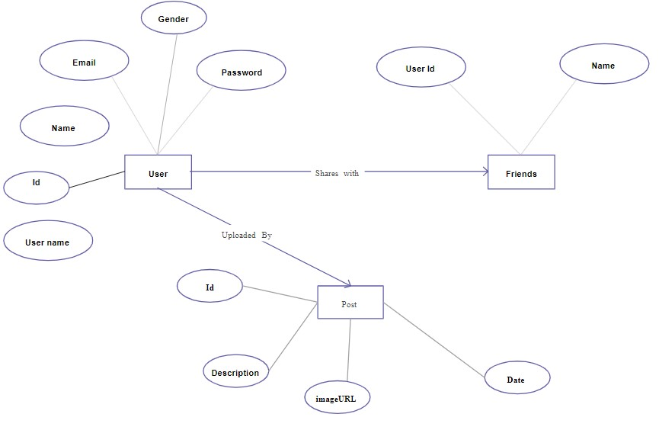

CHAPTER-IX

 **DATA FLOW DIAGRAM** 

**Users  
Management**

**Posts  
Management**

**Comments  
Management**

**Admin  
Management**

**Friends  
Management**

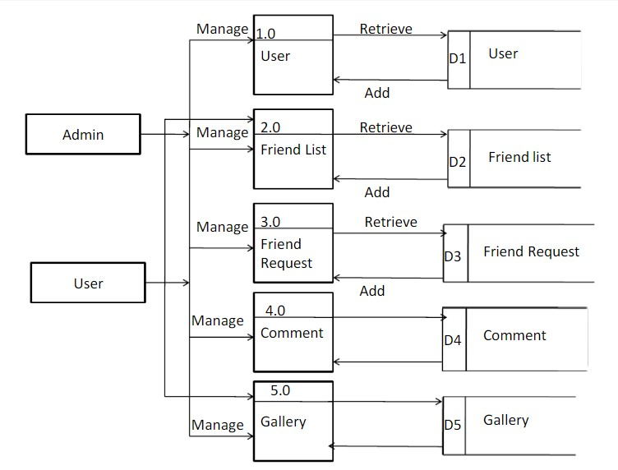

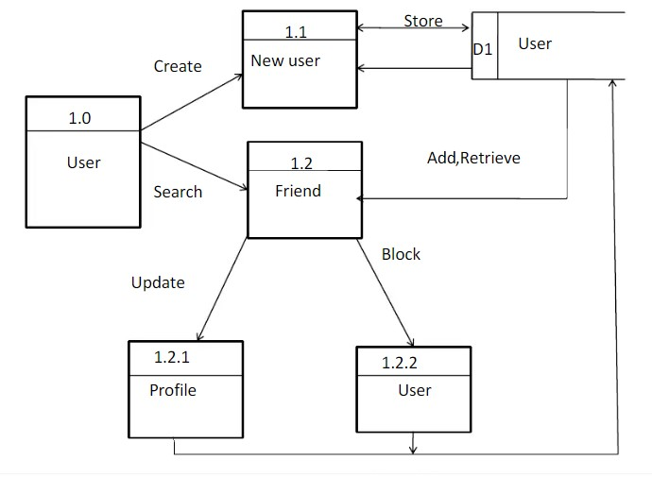

CHAPTER-X

 **DATA SYSTEM INPUT & OUTPUT**

**INPUT LAYOUTS**

**1) Signup Form :-**

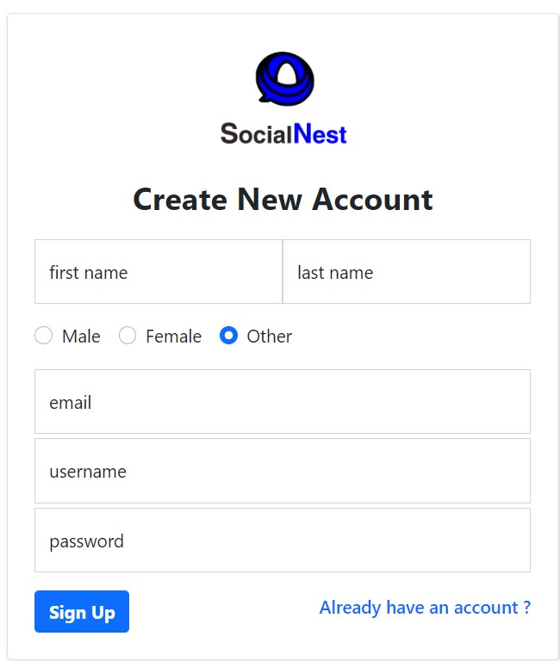

**2) Login Form :-**

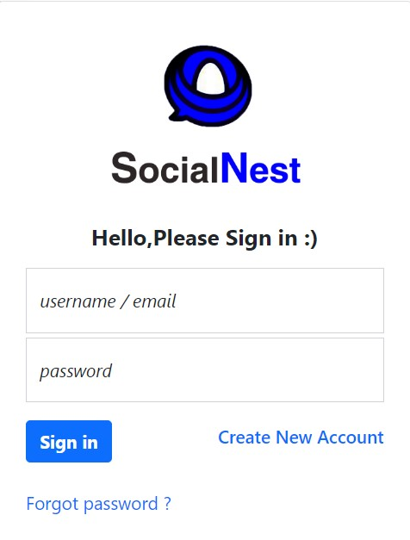

**4) Add New Post Form:-**

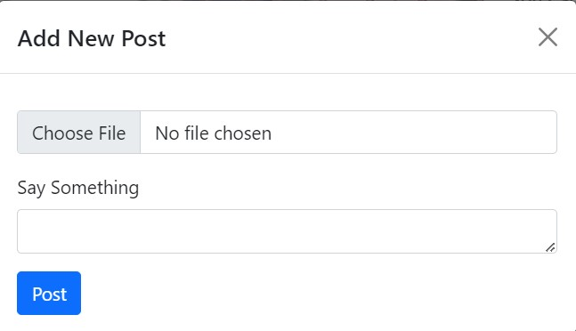

**5) Edit Profile Form :-**

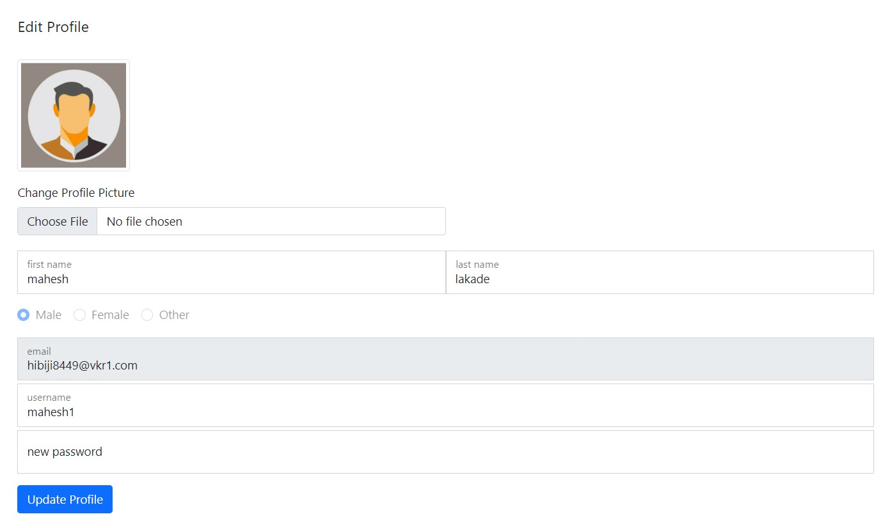

**6) Chat Box Form :-**

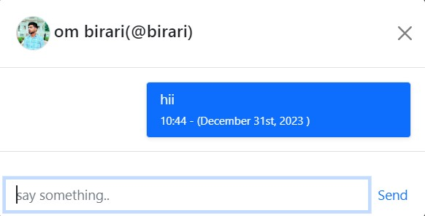

**7) Admin Login Form :-**

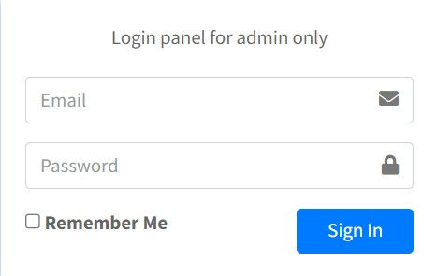

**8) Admin Edit Profile Form :-**

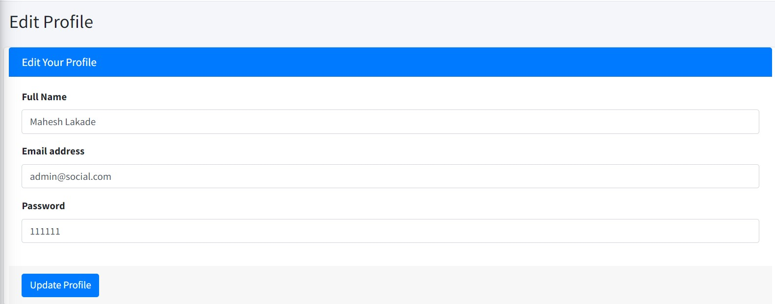

OUTPUT

**1) Wall Page :-**

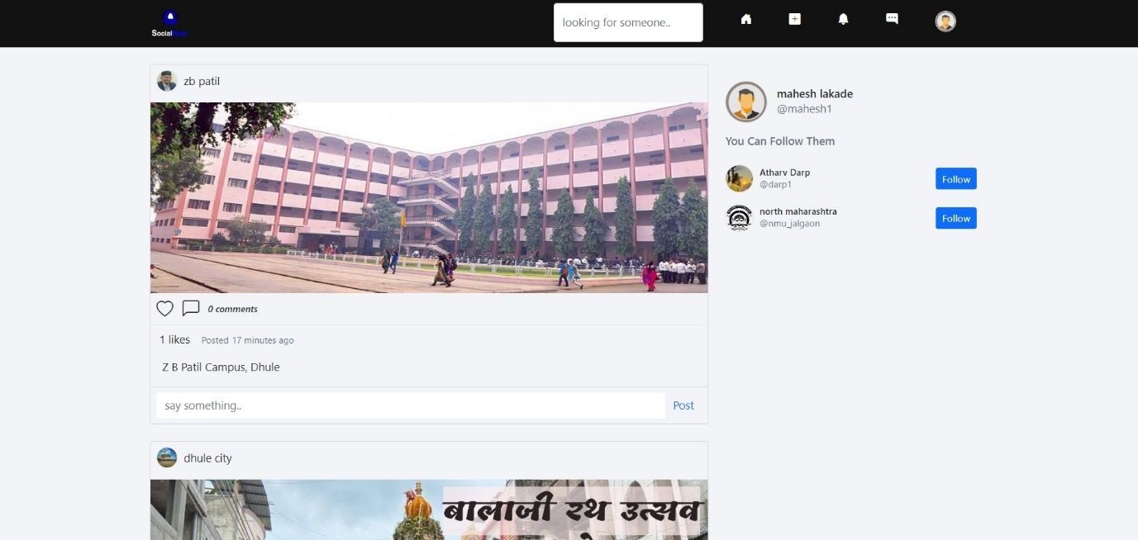

**2) User Post Page:-**

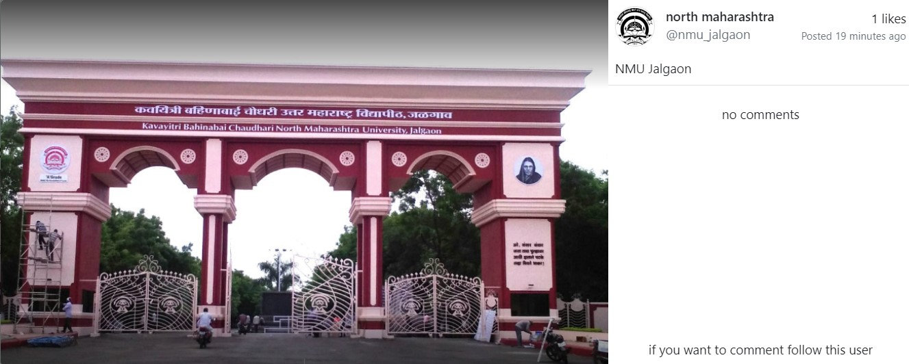

**3) User Profile Page :-**

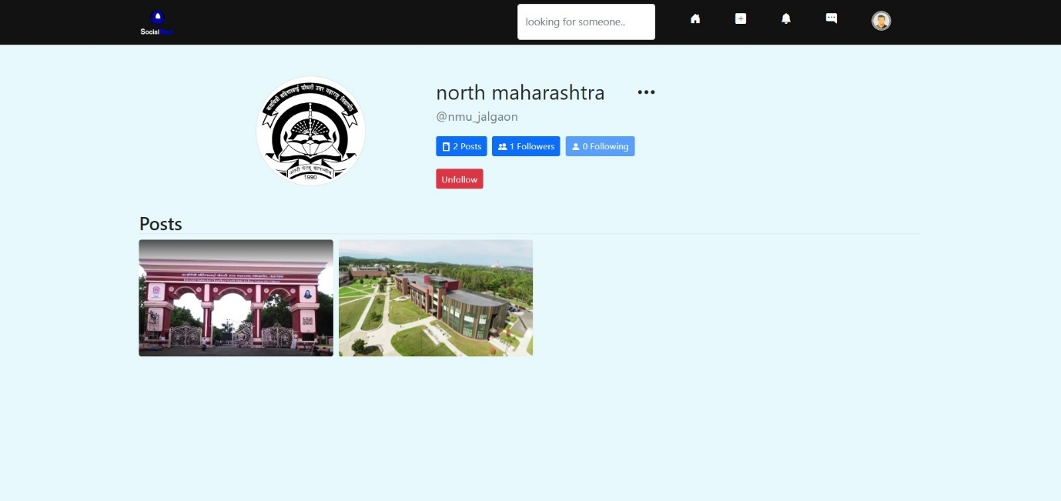

**4) Notification panel :-**

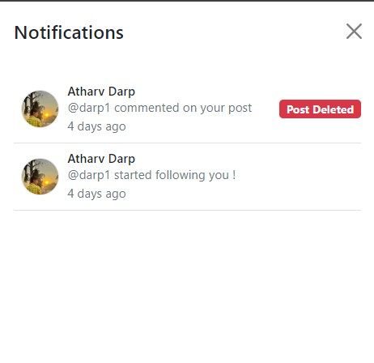

**5) Chat Box Page :-**

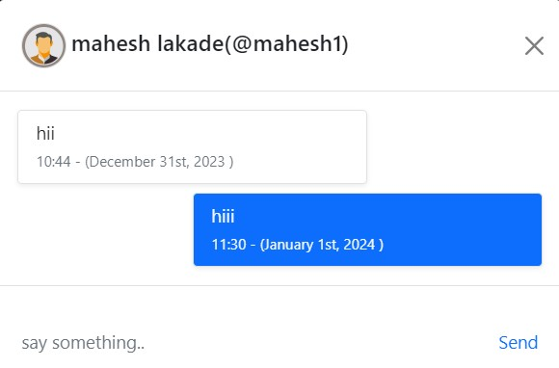

**6) Admin Dashboard Page :-**

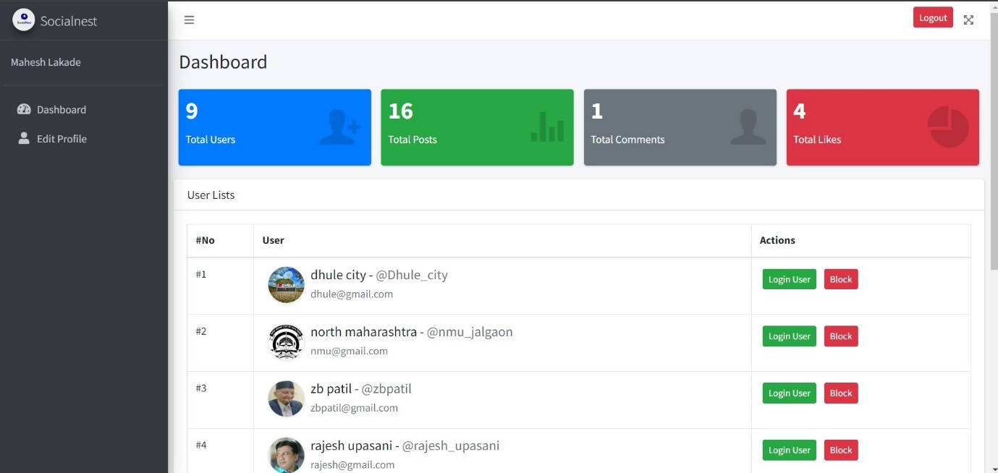

CHAPTER-XI

 **SYSTEM TESTING & IMPLEMENTATION** 

**SYSTEM TESTING:-**

**System level testing must be conducted prior to installation of any system. It invoices.**

1. Preparation of realistic test data in according with the system test plan.
2. Processing the test data using the new equipment.
3. Through checking of the result of all system tests.
4. Reviewing the results with future, operators, and of all system personal.

System level testing is an excellent time for training employees in the operation of the new system as well as maintaining it. Typically, it requires 25 to 35 percent of the total implementation effort.

One of the most effective ways to perform system level testing is to perform parallel operations consist of feeding both system the same input data comparing the data files & output result. Despite the fact that the individual program ware tested, related conditions are likely to occur that were not envisioned. Last minute changes to computer programs are necessary to accommodate these new conditions.

**Implementation :-**

**User manual:-**

1.Start the system and run the website.

2.The navbar display as

**Home:-** It display the Home page.

**Add New Post**:- using this we can upload the post It contain the following form control choose file, text area, post button.

**Notification** :- In this icon you will get a notifications from other users.

**Messages** :- It contains the chat interface using this you can communicate with other persons on real time via text.

**User** :- It contains following pages. Click on particular option, you get the pages as below-

**1. My Profile Page.**

**2.Edit Profile Page.**

**3.Logout.**

**Search** :- Using search form control you can search the users by their usernames or names.

**Notification** :- It contains following report. Click on particular option, you get the report as below-

If you have any problem, consult the system administrator.

CHAPTER-XII

 **SUGGESTIONS & CONCLUSION** 

**Suggestions**:

1. User Education Initiatives:

- Develop user-friendly tutorials and guides to educate users on privacy settings, security measures, and ways to identify and report misinformation.

2. Collaboration with Fact-Checking Organizations:

- Establish partnerships with reputable fact-checking organizations to ensure the accuracy of information circulating on the platform.

3. Regular Security Audits:

- Conduct frequent security audits to identify and address vulnerabilities, ensuring the protection of user data from potential breaches.

4. Community Moderation Programs:

- Implement community moderation programs that empower users to actively participate in maintaining a positive online environment, rewarding positive contributions.

5. User Feedback Channels:

- Create dedicated channels for user feedback and suggestions, fostering a sense of user involvement and addressing concerns promptly.

6. AI-Driven Content Moderation:

- Enhance content moderation through advanced AI systems to proactively identify and remove harmful or inappropriate content.

**Conclusion:**

In conclusion, the success and sustainability of a social media platform heavily depend on its ability to prioritize user safety, privacy, and overall positive user experience. By implementing the aforementioned suggestions, the platform can evolve into a more secure, informative, and engaging space for its users.

In the dynamic landscape of social media, continuous improvement is key. Regularly reassessing and adapting policies based on user feedback, technological advancements, and emerging challenges will contribute to the platform's growth and its ability to meet the evolving needs of its user base. A holistic approach that combines technological innovation, community involvement, and a commitment to ethical practices will position the social media website as a responsible and user-centric platform in the digital realm.